Defect No: 1

Defect Description: Unable to add address in address section.

Test Data:

Email- samplem822@gmail.com

Password - Welcome@123

Steps to Reproduce:

1. Open the Url - https://pondybeauty.com

2. Login with above email and password

3. Click the address section in my account page

4. Enter valid address in address text box

5. Click the add button

Excepted: The application should accept the address.

Actual: No response after the add button is clicked.

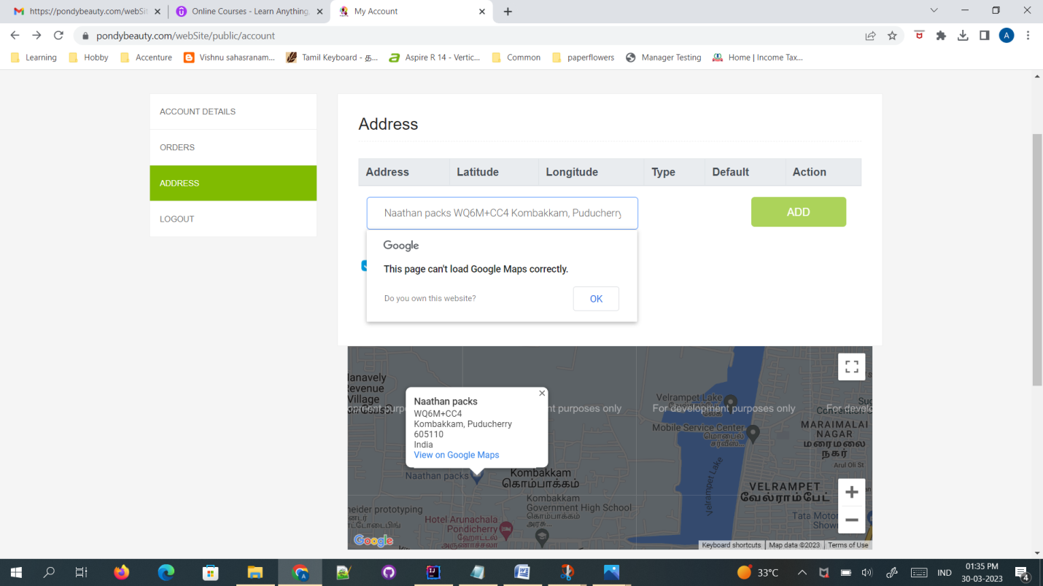

Defect No:2

Defect Description: Checkout button is enabled for an empty cart

Test Data:

Email- samplem822@gmail.com

Password - Welcome@123

Steps to Reproduce:

1. Open the Url - https://pondybeauty.com

2. Login With above email and password

3. Click the view Cart option

4. Click checkout button.

Excepted: The Checkout button should be disabled for an empty cart.

Actual: The Select Destination method page is displayed.

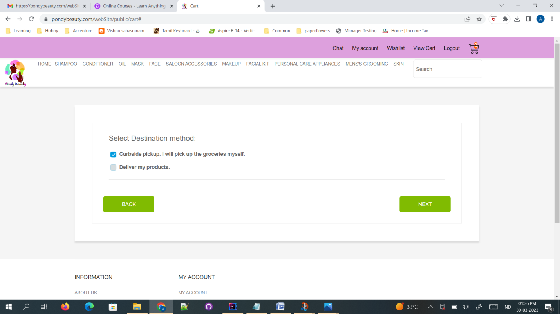

Defect No:3

Defect Description:Order placed With no products

Test Data:

Email- samplem822@gmail.com

password - Welcome@123

Steps to Reproduce:

1. Open the Url - https://pondybeauty.com

2. Login With above email and password

3. Click the view Cart option

4. Click checkout button

5. Select the destination method" Curbside pickup. I will pick up the groceries myself".

6. Select the payment method "Cash on delivery"

7. Click next button

Excepted: The message should be displayed " select product to place an order".

Actual: The message displays "It's Ordered".

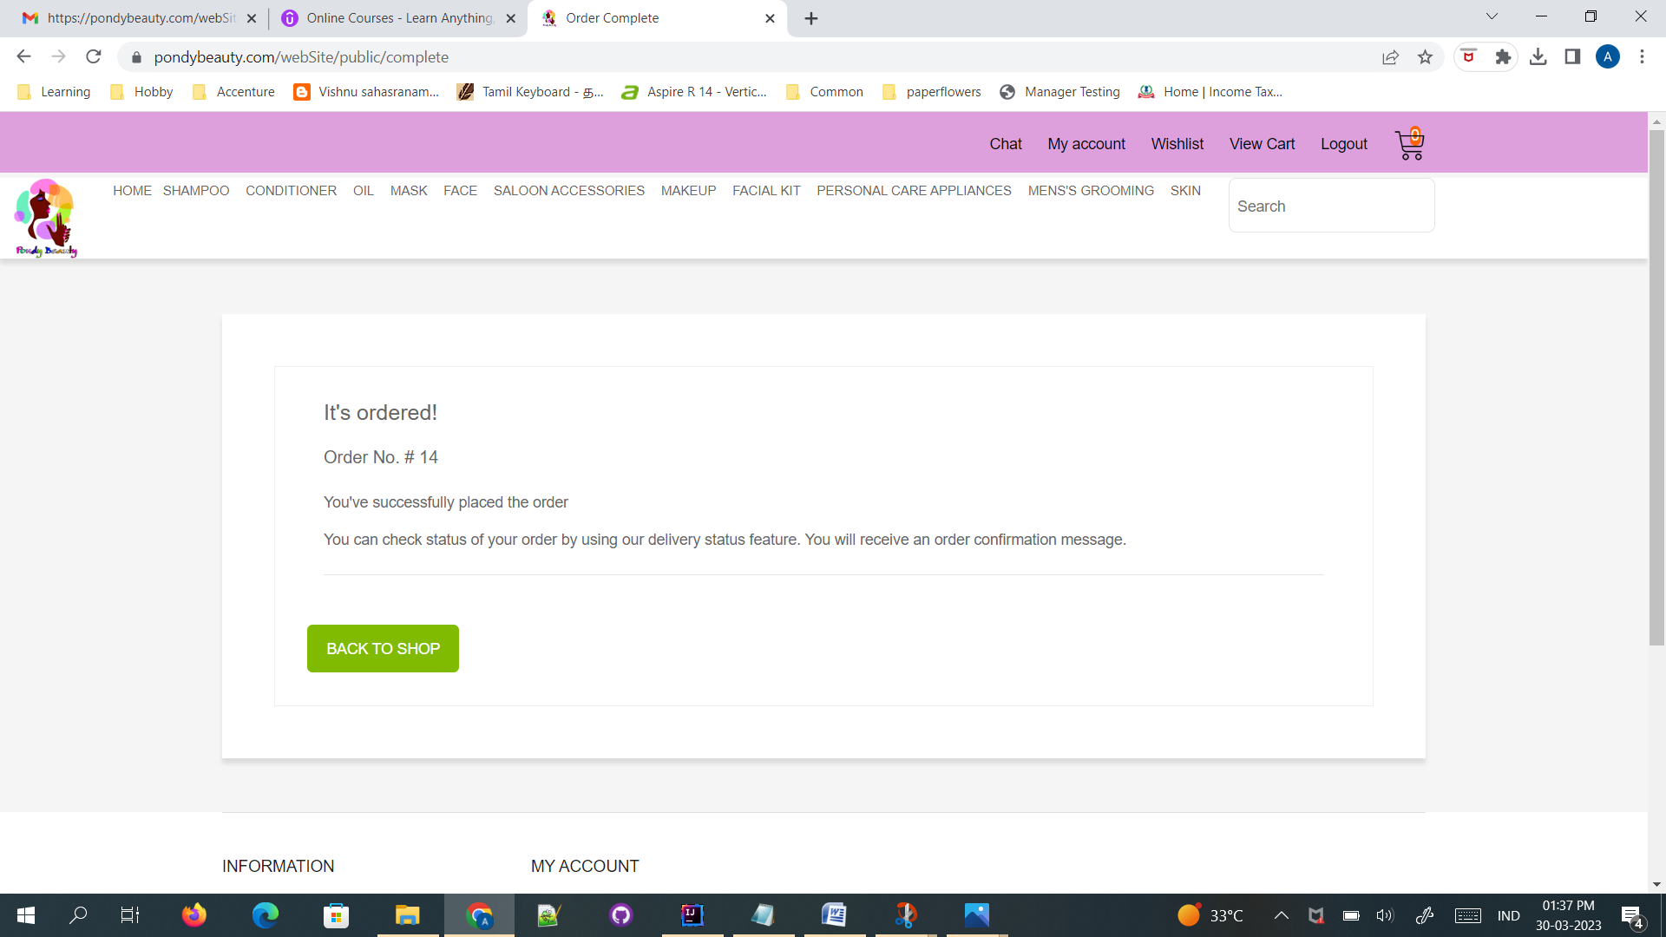

Defect No:4

Defect Description: Search results are not displayed when search textbox is entered with product name.

Test Data:

Email- samplem822@gmail.com

Password - Welcome@123

Steps to Reproduce:

1. Open the Url - https://pondybeauty.com

2. Login with above email and password

3. Click the Search text box

4. Enter the existing product Name "StBotanica Moroccan Argan Hair Shampoo"

Excepted: The product with image should be displayed

Actual: Search results are not displayed

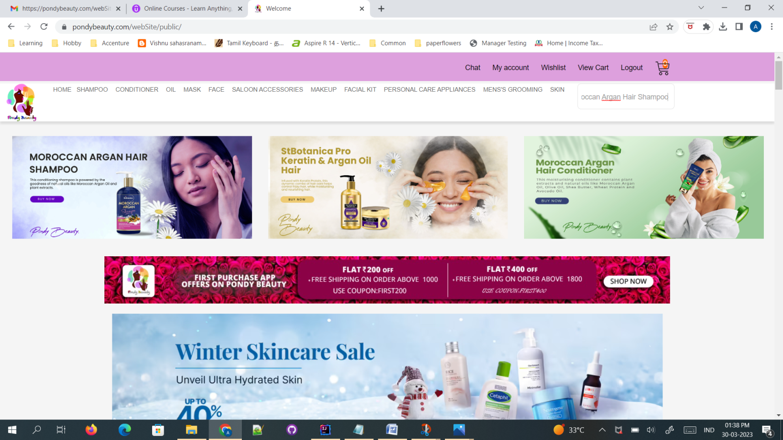 Defect No:5

Defect Description: Cancel order option is not available

Test Data:

Email- samplem822@gmail.com

password - Welcome@123

Steps to Reproduce:

1. Open the Url - https://pondybeauty.com

2. Login with email and password

3. Select the product need to be order

4. Click the product to add to cart option

5. Click checkout button

6. Select the destination method

7. Select the payment method"Cash on delivery" and click next button

8. Click the my account page and

9. Click orders section

Excepted:The page should displayed with order details and cancel order option

Actual: The page displayes with order details.

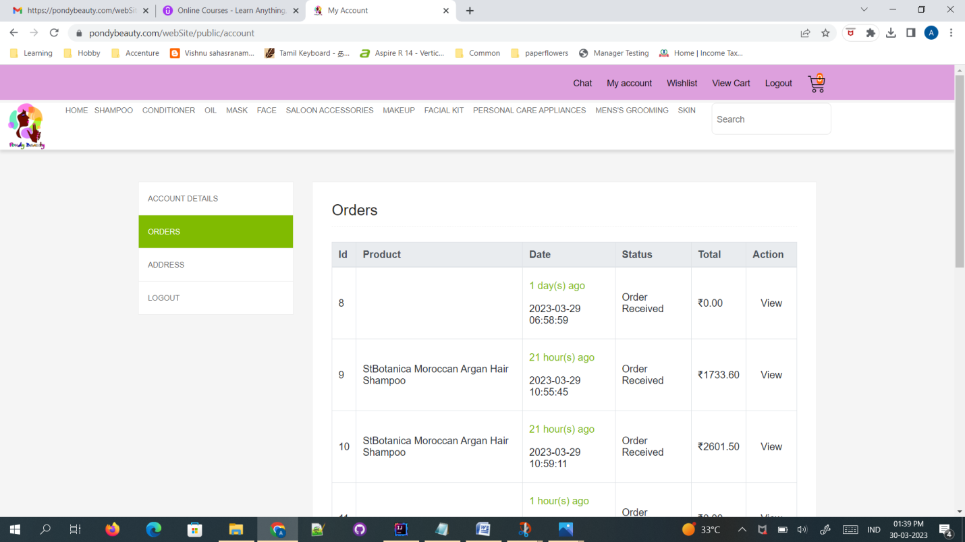

Defect No:6

Defect Description: Message not displayed when Wishlist is empty

Test Data:

Email- samplem822@gmail.com

Password - Welcome@123

Steps to Reproduce:

1. Open the Url - https://pondybeauty.com

2. Login With above email and password

2. Click the wishlist option

Excepted: The page should displays with "Your Wishlist is empty"

Actual: The page displayed with Wishlist tabs

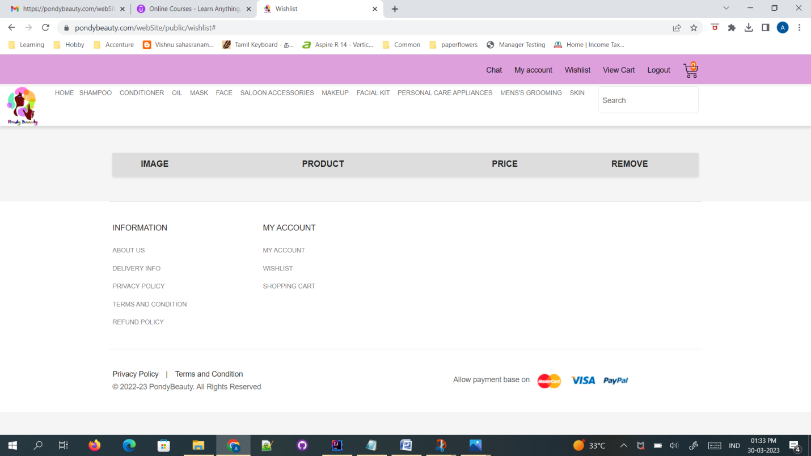

Defect No:7

Defect Description: Wishlist option there is no add to cart option

Test Data:

Email- samplem822@gmail.com

password - Welcome@123

Steps to Reproduce:

1. Open the Url - https://pondybeauty.com

2. Login with above email and password

3. Select the products that need to be order

4. Add the product to wishlist option

5. Click the wishlist option.

Excepted: The add to cart option should be displayed

Actual: Add to cart option not displayed in wishlist Option.

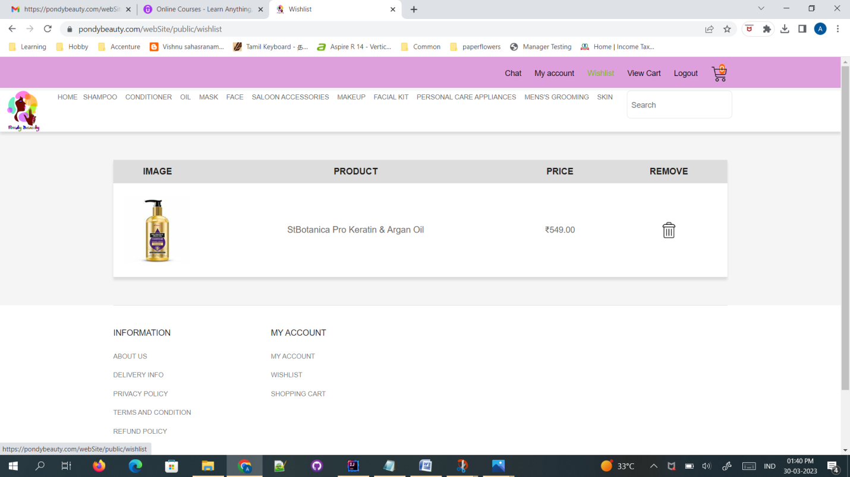

Defect No:8

Defect Description: Changing quantity in Cart alters the table alignment.

Test Data:

Email- samplem822@gmail.com

Password - Welcome@123

Steps to Reproduce:

1. Open the Url - https://pondybeauty.com

2. Login with above email and password

3. Select the products that need to be order

4. Click the add to cart option

5. Increase/Decrease the product quantity.

Excepted: The size of the product displayed should not change on increasing/decreasing the quantity.

Actual: The size of the product is changed.

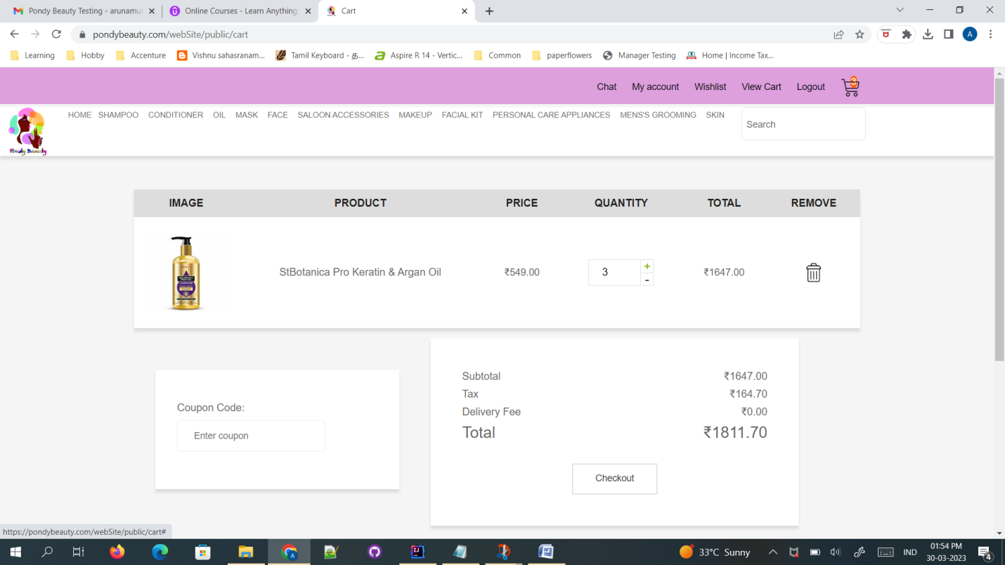

Defect No:9

Defect Description: View button in orders is not enabled.

Test Data:

Email- samplem822@gmail.com

Password - Welcome@123

Steps to Reproduce:

1. Open the Url - https://pondybeauty.com

2. Login with above email and password

3. Go to My Account and Select Orders from the Menu.

4. In orders section View button under the Actions column is not enabled.

Excepted: View button is enabled, in order to view the ordered items

Actual: View button is disabled.

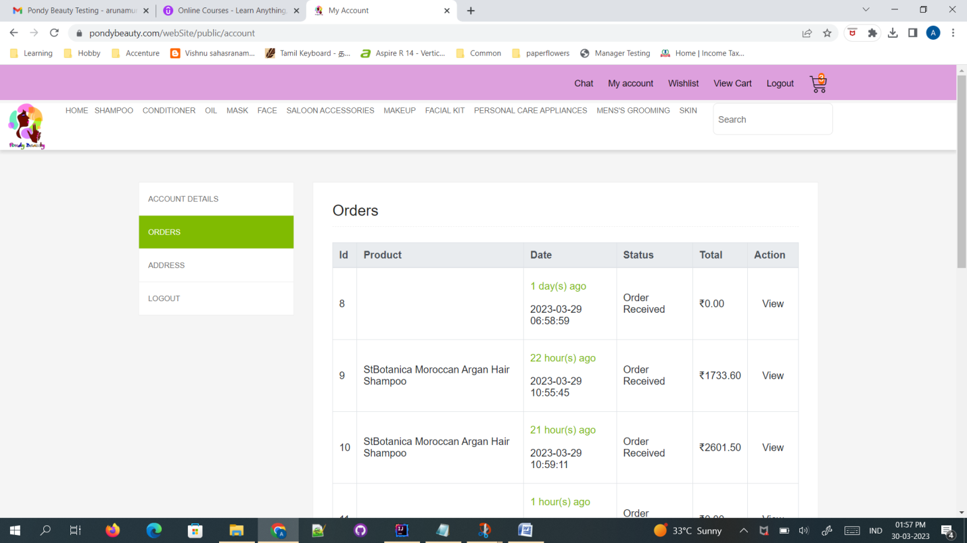

Defect No: 10

Defect Description: In orders the product name is not displayed when we view the order.

Test Data:

Email- samplem822@gmail.com

Password - Welcome@123

Steps to Reproduce:

1. Open the Url - https://pondybeauty.com

2. Login with above email and password

3. Go to My Account and Select Orders from the Menu.

4. In orders section Click view button from the Action column.

5. The Order is displayed with the image, no order description is present.

Excepted: Order with Image and Product name is displayed.

Actual: Order with Image alone is displayed.

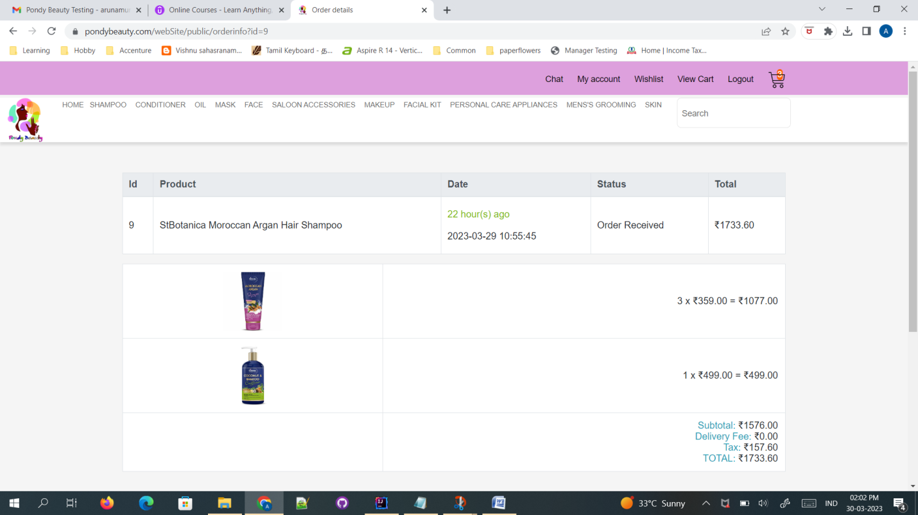

Defect No: 11

Defect Description: Adding values to quantity text box does not calculated the Total Amount

Test Data:

Email- samplem822@gmail.com

Password - Welcome@123

Steps to Reproduce:

1. Open the Url - https://pondybeauty.com

2. Login with above email and password

3. Go to cart.

4. Choose the product and enter the quanity input in the textbox

5. The Total amount is not displayed for the entered quantity input into the textbox.

Excepted: In cart add value input to the quantity textbox for the selected product, the total amount is calculated as per the entered quantity input.

Actual: In cart add value input to the quantity textbox for the selected product, the total amount is not calculated to the entered quantity input.

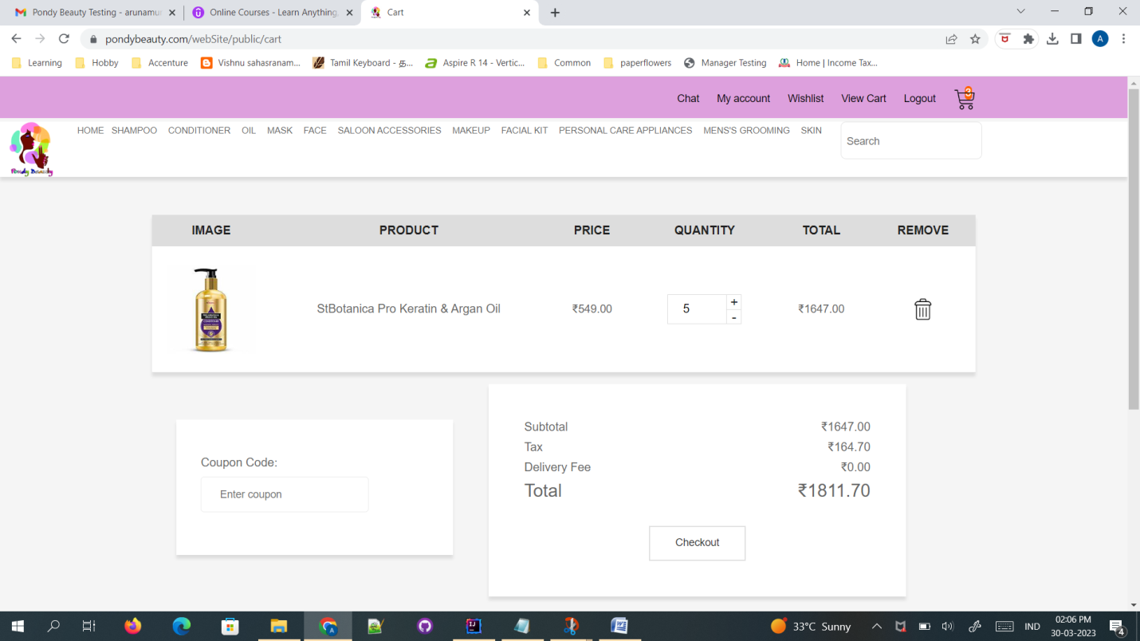

Clarification:

1. Only cash on delivery is available in payment section

2. Unable to click Top rated products.

3. Comment option is not available.

4. Rating options is not available.

5. By changing the filter by price, the product images decreases.

6. Two view cart options are displayd in the menu.

7. Account page has additional logout option.

8. No suggested images are shown.

9. Clicked logout, did not ask for confirmation message, it logged out immediately.

10. Orders display only the first product in the orders.

11. Order ID displayed in orders, need to verify if it is required.

12. Order tracking status not visible.